Assignment 2 (AWS)

**For required library installation  
use these commands as sudo**  
  
  
**sudo yum install numpy  
  
sudo yum** **install scipy  
  
sudo yum** **install pandas  
  
sudo yum** **install scikit-learn**

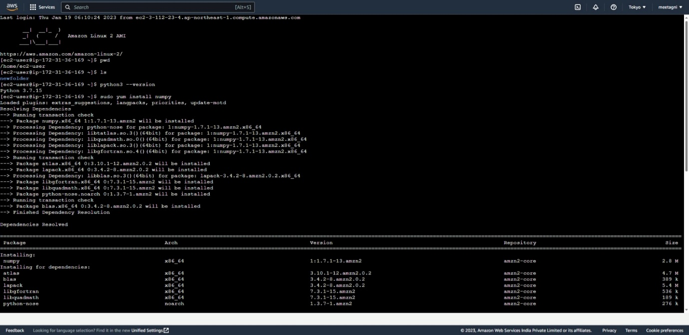

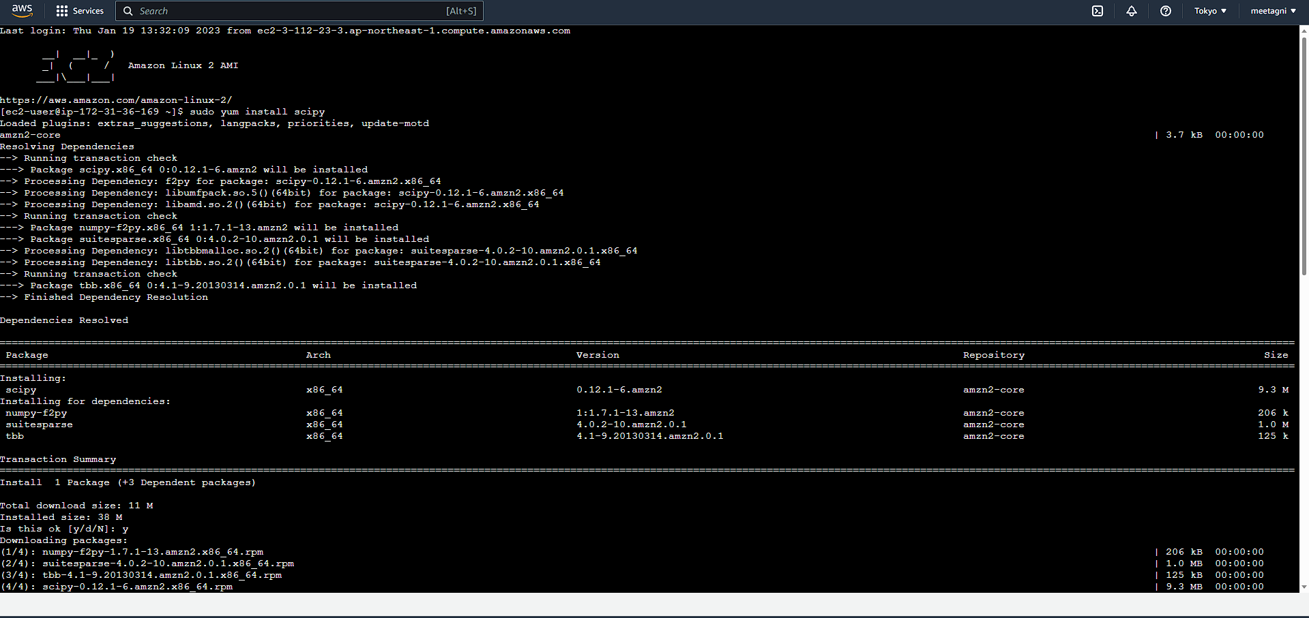

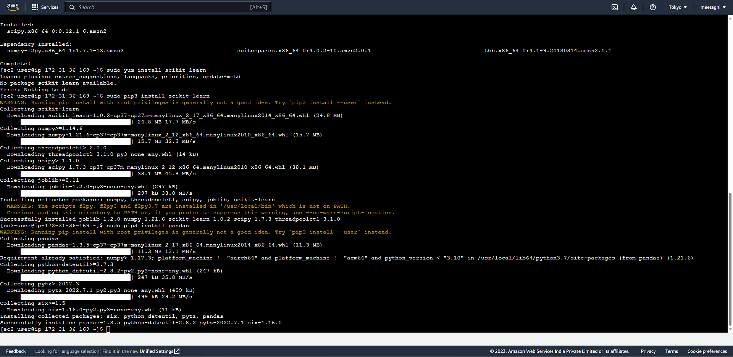

**EXECUTE THE  PYTHON CODE ON EC2 INSTANCE**  
  
  
**(I)Using GIT CLONE**

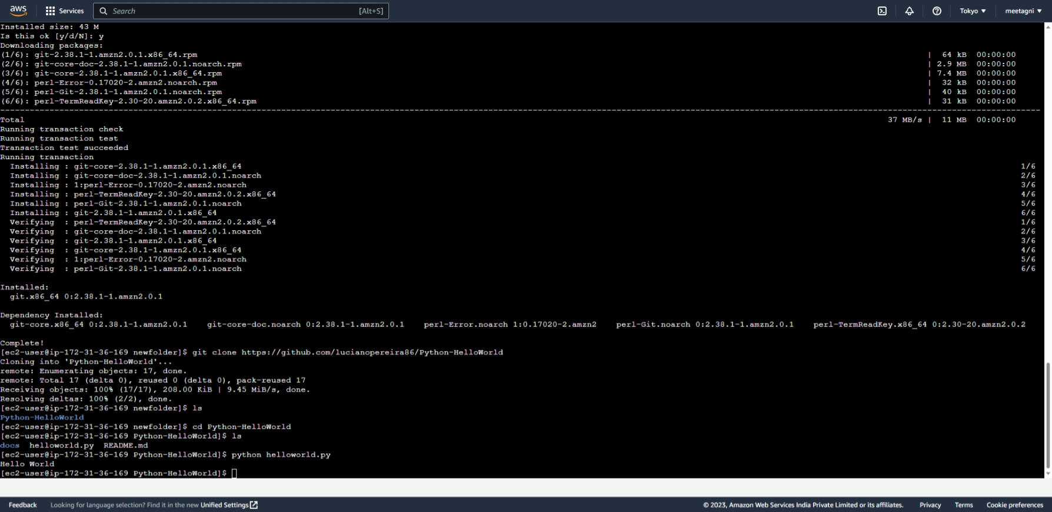

**(II) Using EDITORS VIM/VI-**

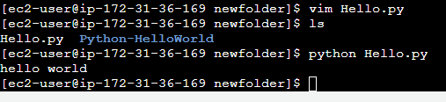

**(III) local machine  file folder**

